EXPERIMENT-2

**Aim**:

To configure initial Switch Settings.

**Software Used**:

Cisco Packet Tracer

**Commands Used:**

1. *enable*: It allows the user to enter EXEC mode, the prompt will change as shown in fig (1).



Figure 1: Switch EXEC mode

1. *show running config*: This allows the user to view the current configuration of the switch, it ranges from ethernet port to all the configurations of the switch.

Figure 2: Switch configuration

1. *configure terminal*: It allows the user to configure the parameters of the terminal such as hostname, password, encryption etc.

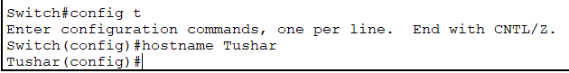

Figure 3: Hostname configuration

1. *hostname*: It is used to configure the hostname parameter as shown in fig (3).
2. *password*: It is used to set the password to the console. Fig (4)

Figure 4: Login Password configuration

1. *login*: It is used after password command, to set the password for User Access Verification as shown in fig (5).

Figure 5: User Login Verification

1. *exit*: This allows the user to exit the EXEC mode, or CLI session.
2. *secret*: It is used to lock the EXEC mode of the terminal. Fig (6)

Figure 6: EXEC mode Login Verification

1. *service password-encryption*: It is used to encrypt the password. Fig (7)

Figure 7: Password Encryption

1. *banner motd*: It is a feature which allows the user to configure messages that anyone logging on the switch sees. These messages are known as Message of the Day. Fig (8)

Figure 8: Motd configuration

1. *copy running-config startup-config*: It allows the user to save the configuration file to NVRAM of the switch, which can be used when the switch is rebooted. It creates a startup script which ensures that changes made are not lost. Fig (9)

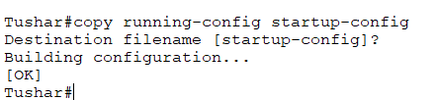

Figure 9: Startup configuration

**Conclusion**:

The switch was configured successfully.